Experiment No. 2
GENERATION OF SQUARE WAVE USING PROTEUS
Objectives
- To generate a square wave using AT89C51.
- To study port taggling operation.
- To observe wave from using an oscilloscope in proteus.
Program:
ORG 0000H
UP: SETB P2.0
ACALL DELAY
CLR P2.0
ACALL DELAY
SJMP UP
DELAY: MOV R4,#35
H1:MOV R3,#255
H2:DJNZ R3,H2
DJNZ R4,H1
RET
END

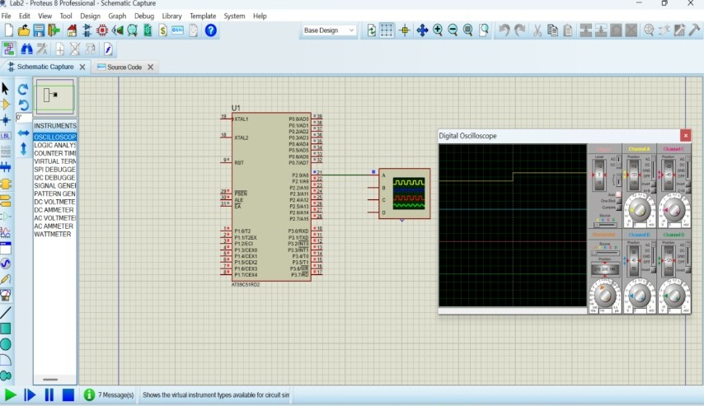
Output:

